

Project Report

Topic- Sentiment Analysis of Restaurant Reviews

Using IBM Cloud

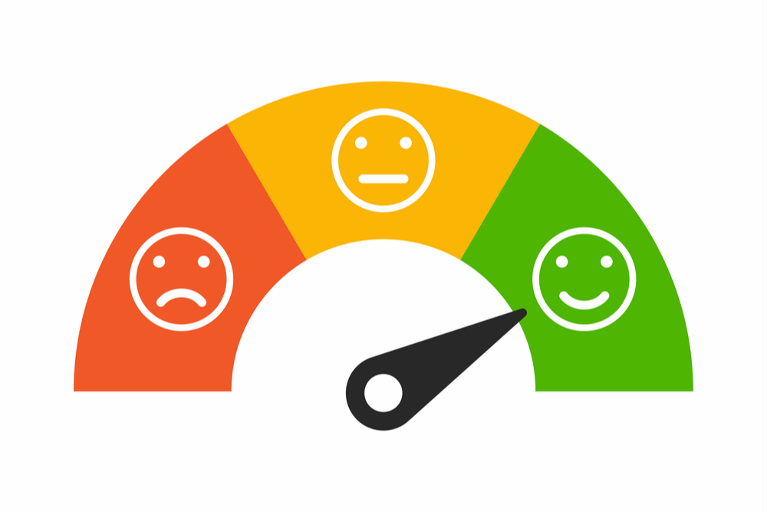

*Submitted by- Ketaki Kavi*

[*ketaki.ulhas2019@vitbhopal.ac.in*](mailto:sneha.mohan2019@vitbhopal.ac.in)

**1.Introduction**

1.1 Overview & Purpose of the Project

Today Sentiment Analysis is a powerful marketing tool that enables a business company to understand the customer emotions towards the product or service.It allows to gain an overview of the wider public opinion behind a service or a product. Sentiment Analysis serves the purpose of helping a brand secure its edge over the other competitors by efficient decision making.

Everyday data is generated at a humongous rate and it is quite humanly impossible to analyze it.People share their opinions about a service or product over social media,curated websites twitter etc. in order to make the process of analyzing these opinions or reviews, various machine learning techniques can be applied.This is where Sentiment analysis comes into picture.

Talking about the restaurants, although people still rely on the verbal review of any hotel ,their online reviews and rating also matters. These reviews pivot customers to the restaurants. To improve their services and to get the overall feedback of the customers, sentiment analysis is done. Sentiment analysis is called finding the opinion from a large dataset which helps to analyze which restaurant is the best for customers who directly access the good reviews for the restaurant.System of sentiment analysis helps to convert unstructured information into structured information of public reviews, products, service, and brands. This helps in the field of commercial areas like marketing analysis, public dealings, reviews of product, promoters and scoring, feedback of product and service of products.

Sentiment analysis has different scopes which can be applied for three levels like document level, sentence level, sub sentence level. Using document level it can get hold of paragraphs or complete documents. By obtaining a single sentence it helps to define a document . Sub expression can be achieved using sub sentences. Data analysis estimates that 80% of the world's data is unstructured. Most of the data starts from electronic mail, chats, community media, credentials and articles.

**2.** **Literature Review**

Consumer satisfaction is one of the most important factors in marketing and research in terms of the behavior of consumers. For example, hotel consumers who receive excellent service will recommend it to others by word of mouth . [3]Text mining, or the process of retrieving data from a collection of documents, is often done with software or analysis tools manuals. A text mining analysis can produce information that can be used to increase profits and improve services. [2]Sentiment analysis is used to find the author's opinions about a specific entity. A sentiment analysis of a review is an analysis of an opinion about a product. Based on this information Natural Language Processing (NLP), text analysis, and computational parts are used in sentiment analysis to eliminate or extract unnecessary parts of the sentence to determine if it is negative or positive.

The computing power provided by A. Sadilekhas [1] to monitor health and epidemiology continues to grow. Future work will include developing an end-to-end system that can identify restaurant risks automatically. On Twitter, online users can discover individuals who may be ill with a foodborne illness from a colony.

**3. Theoretical Analysis**

3.1 Architecture Diagram

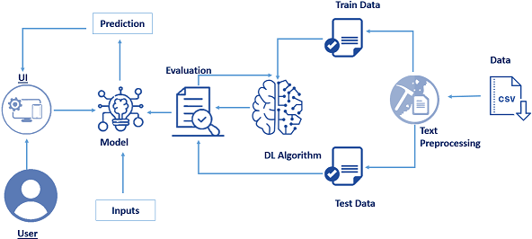

On the basis of reviews and ratings, most customers choose the best restaurants. Review systems and models are essential to any kind of model or system. This problem is approached by using natural language processing (NSL) and machine learning techniques based on review text content analysis. Using the above method, we can classify the review as positive or negative, and as well as see how many positive or negative reviews there are in total. By combining a predefined dictionary of words with an algorithm, we can classify the reviews on the basis of positive and negative reviews.

Users can enter feedback in a web application, the feedback is analyzed the model built, and predictions are displayed on the user interface

3.2 Project Requirements

* Python 3
* Anaconda Navigator
* Jupyter Notebook
* Spyder
* Flask
* Python Libraries
  + Pandas
  + Numpy
  + Scikit Learn
  + Keras
  + Pickle
  + NLTK

**4. Working**

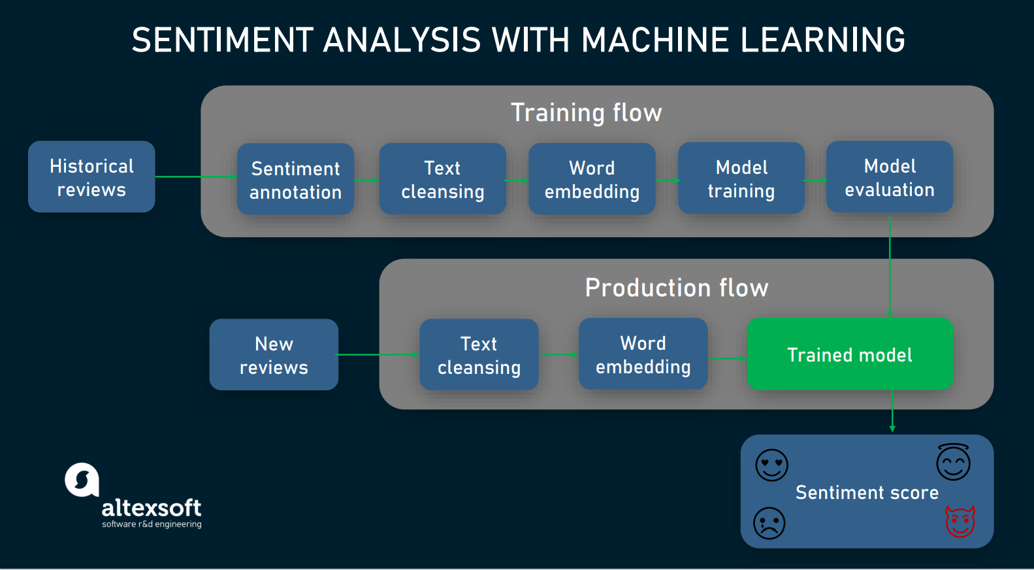

* The important part is training the model on the existing data available.
* In this project we use the Zomato review dataset.Getting the dataset is a part of data collection.
* Then comes Cleansing the data, here the numbers and the text data is separated, special characters , punctuations are removed, the text is made in lowercase.
* Then tokenization, vectorization and stemming are performed on the dataset using the nltk library of python.
* This data is then split into test and training data.
* The training is then fed to the neural networks.
* Then the prediction on the trained model is made using new text and then sentiment analysis is made based on the previous data.

**5. Results and outcomes**

Restaurant Review App:

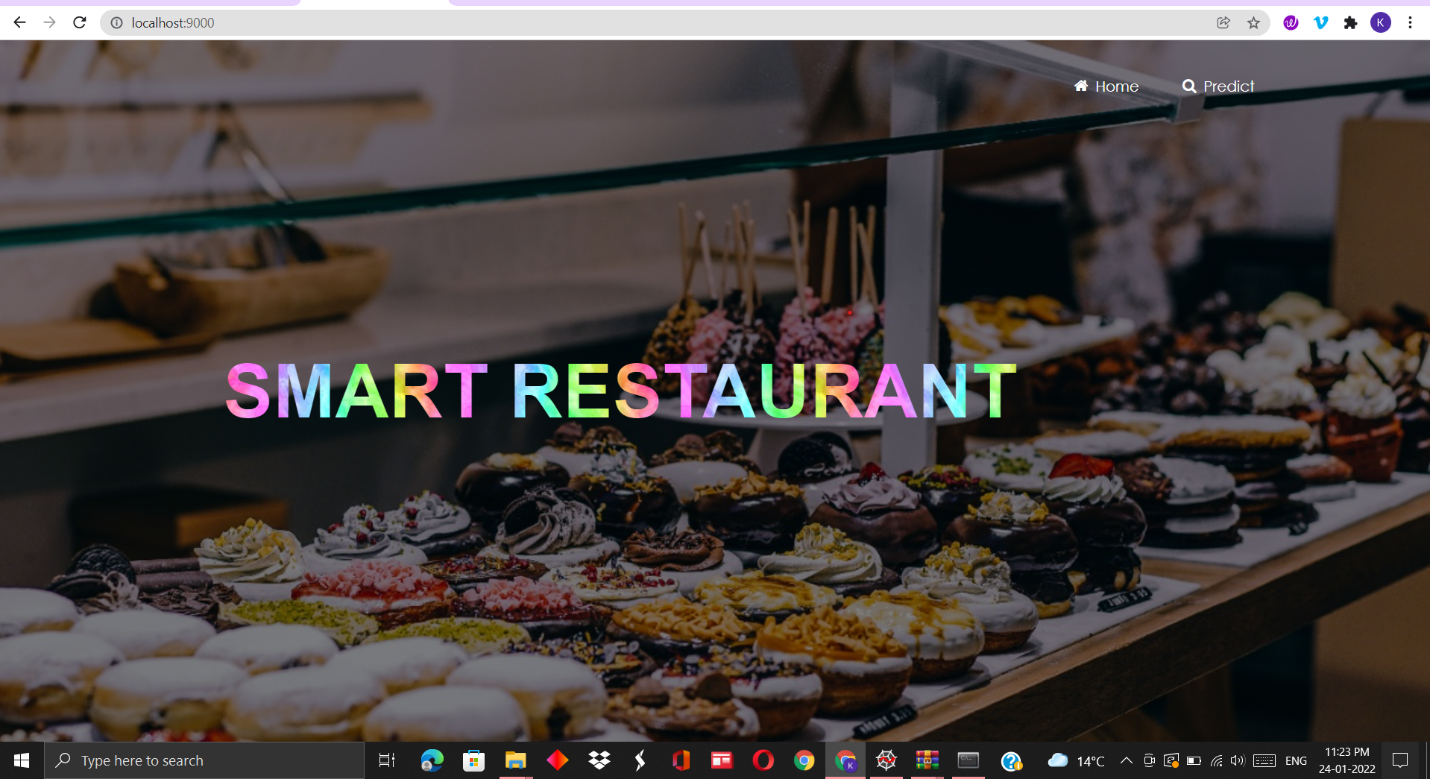

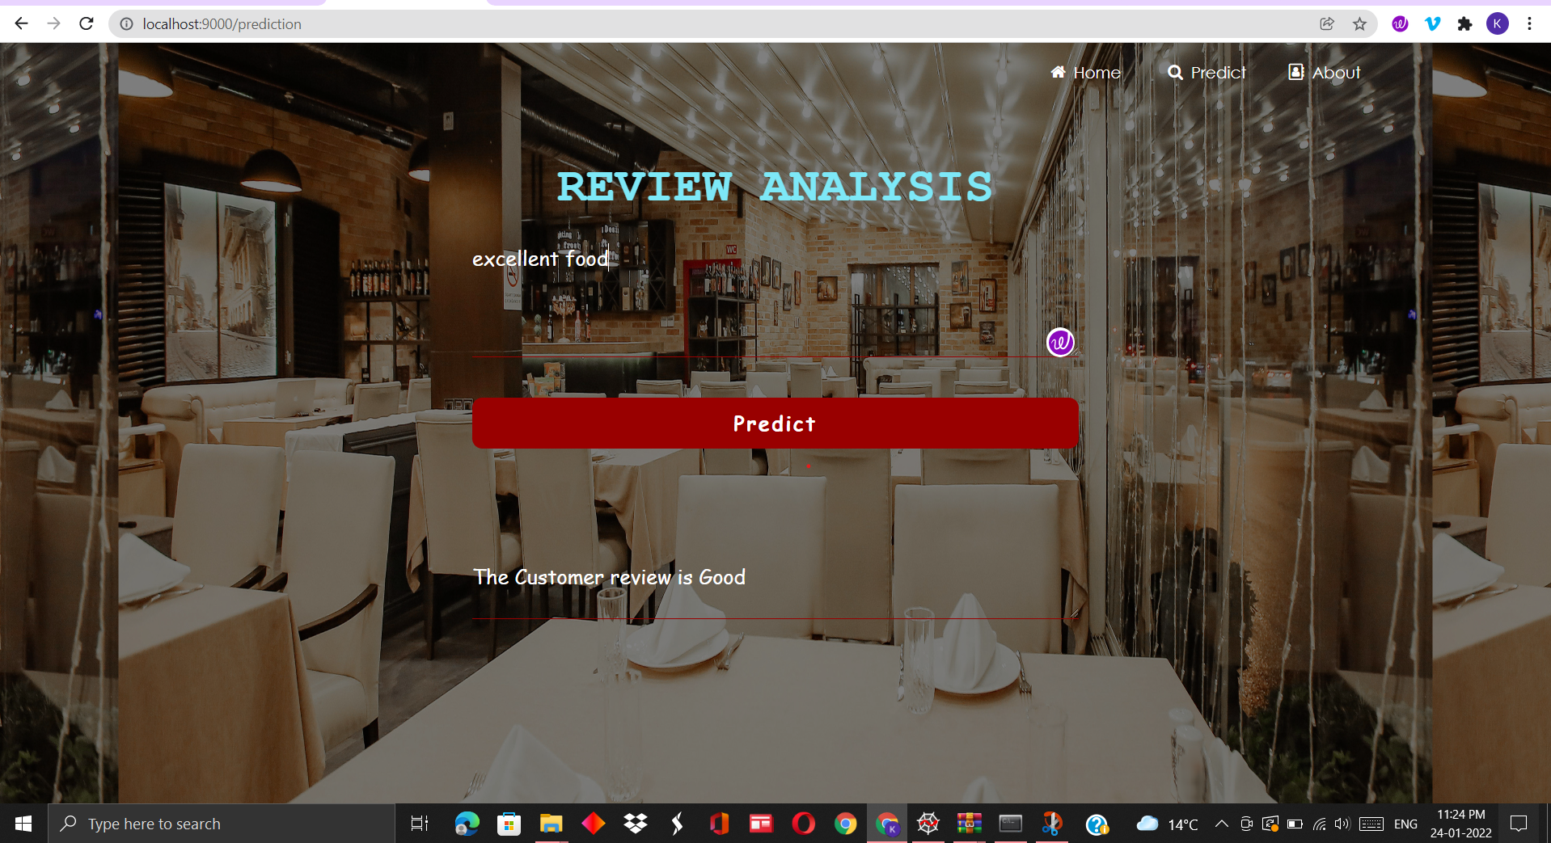

Flask Deployment:

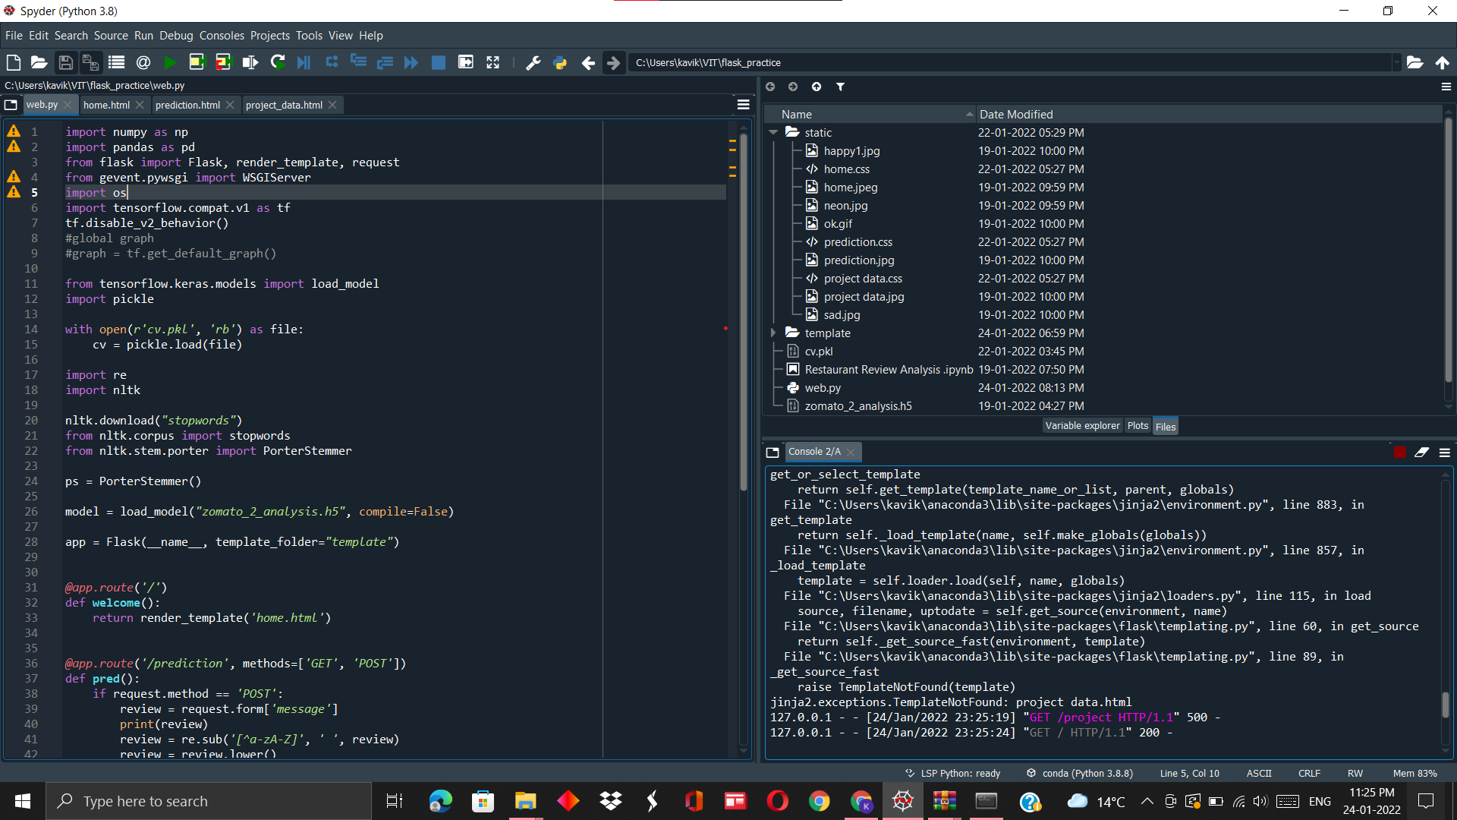

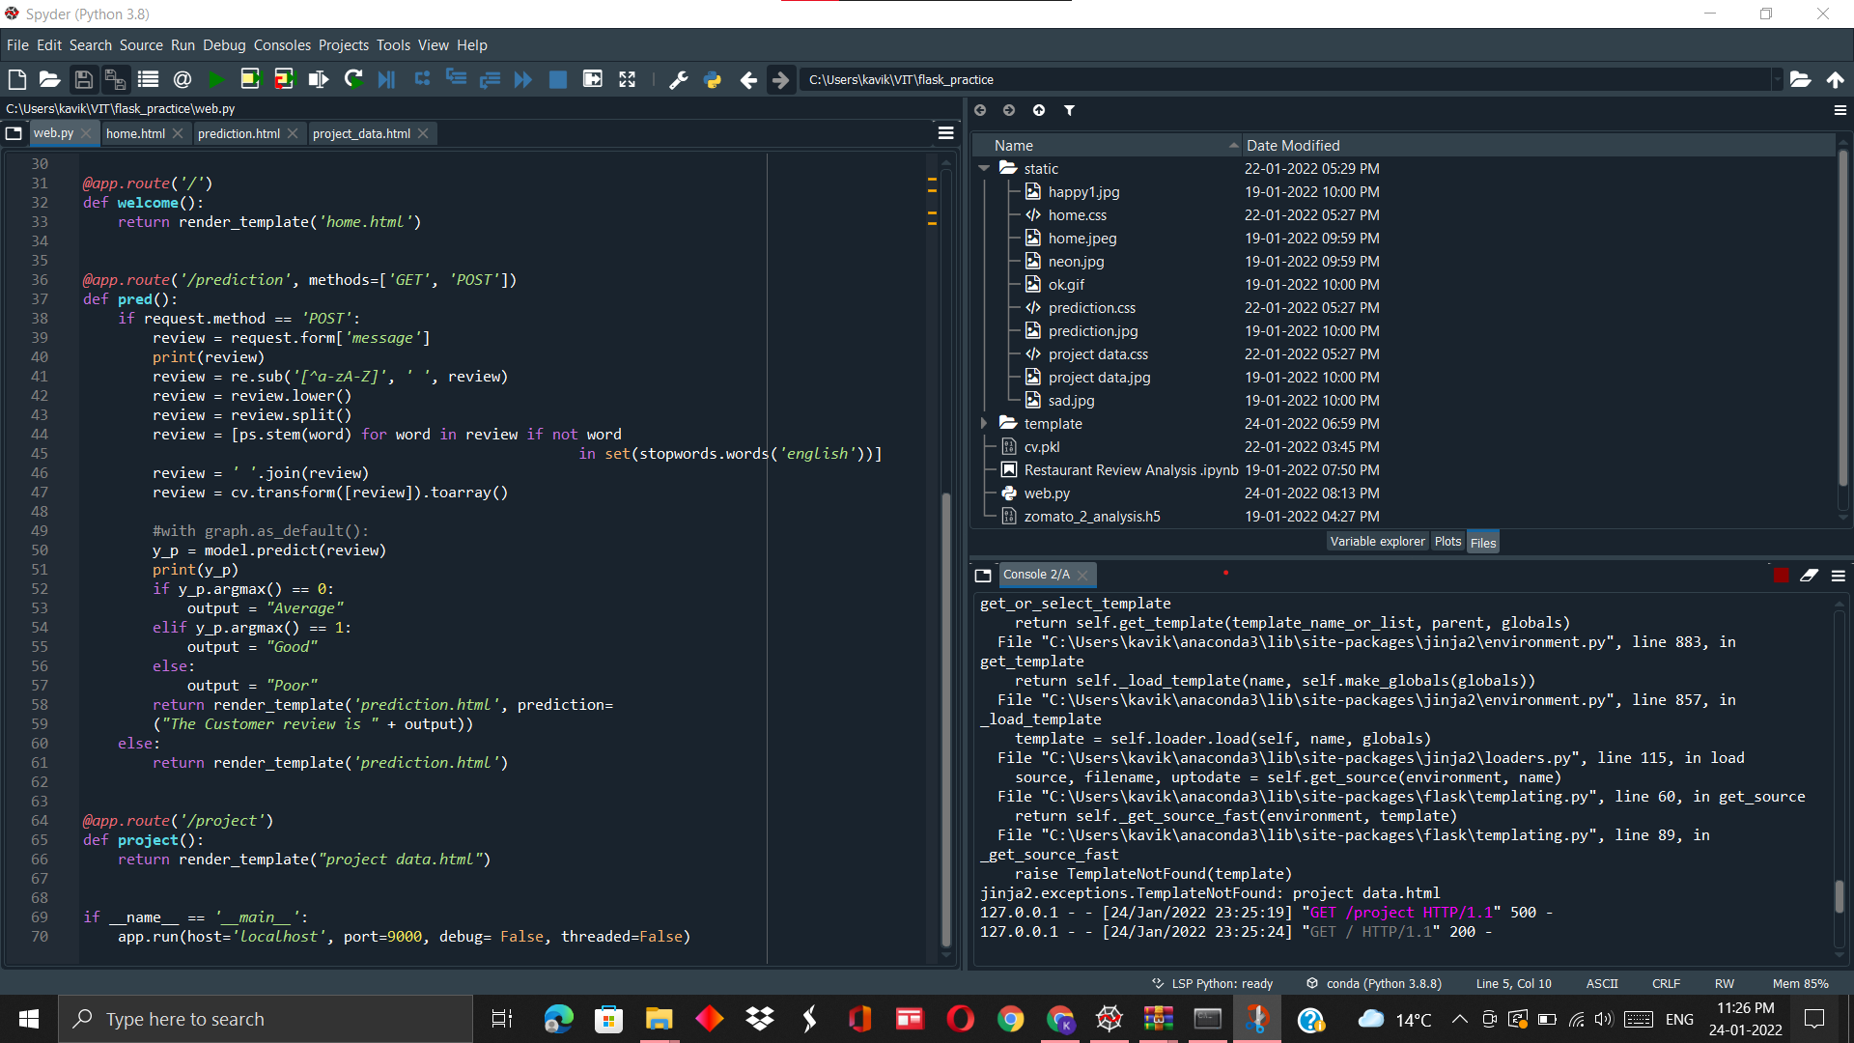

**5. Advantages and Disadvantages**

An organization or group whose public perception is important for their success - no matter how it is defined - can benefit from sentiment analysis. On social media, blogs, and online forums, millions of people are busy discussing and reviewing businesses, companies, and organizations. The opinions of these people are being 'listened to' and analysed. Those being discussed are taking advantage of this enormous amount of data by using computer programs that not only locate all mentions of their products, but also determine the emotions and attitudes behind them. Sentiment analysis helps businesses understand what is being said about their products and services, so they can take action accordingly. They can quickly recognize any negative sentiments being expressed, and turn poor customer experiences into the kind of experiences that customers appreciate. This can result in better products and services, and it will allow them to formulate marketing messages that will appeal to their target audience. This will ultimately lead to increased revenue and sales.

One of the biggest limitations of sentiment analysis is that it is not completely accurate. Sentiment analysis can identify and analyse many pieces of text automatically and quickly. The problem is that computer programs have difficulty recognizing things like sarcasm and irony, negations, jokes, and exaggerations, which a person would be able to easily detect. A failure to recognize them can cause results to be skewed.

**6. Conclusion**

Sentiment analysis can be useful to many aspects of business from a monitoring of products analytics and from a customer production. By incorporating into existing systems and brands it is ready to work more rapidly with more accuracy for useful works .To examine critically and to bring out the essential elements or give the essence to analyze a data. To examine carefully and in detail so as to key factors, possible results.

**7. Future Scope**

Today Sentiment analysis is looked at only as a classification of negative or positive. But in future it will delve deeper in understanding and signify the conversations and what they reveal about the consumers. This will help brands to more effectively customize and deliver their services.

**8. References**

[1] A. Sadilek, S. Brennan, H. Kautz, and V. Silenzio. Nemesis: Which restaurants should you avoid today? In HCOMP, 2013.

[2] R. Feldman, "Techniques and applications for sentiment analysis ,"

Communications of the ACM, vol. 56, no . 4, pp.82-89,2013

[3] E. Haddi, X. Liu, and Y. Shi, "The role of text pre-processing in

sentiment analysis," Procedia Computer Science, vol. 17, pp.26-32,2013